GUIDELINES FOR PREPARATION OF FULL PAPERS
FOR PAMIR 2019
First name (initials) NAME^{1*}, First name (initials)NAME* …
¹ LISM, URCA, Laboratory of Engineering and Materials Science (LISM - EA 4695), URCA,
B.P. 1039, 51687 Reims Cedex 2, France.
.
²LAB/Address…
*Corresponding author: name@univ-reims.fr
Abstract: The present sample contains information on preparation of the full paper for the XI International PAMIR International Conference - Fundamental and Applied MHD, to be held from 1 – 5 July, in Reims, France. The abstract (10 lines maximum) should contain the most important information about the paper. Please avoid citations and symbols other than normal text.

Key words: Up to five, in alphabetical order, separated by commas
1. Introduction The manuscripts should be typed using Times 12 characters and the lines will be spaced with a single space. The text will be typed within a 160 x 250 mm frame on A4 format paper. The manuscript should be written clearly with regard to content and appearance, classified by the decimal system with underlining the paragraph headings of one numeral. You may type over sections of the present file, cut and paste into it (Edit | Paste Special | Unformatted Text), and/or use markup styles.
The length of the full paper should be 5 pages maximum. The references should be quoted in order at the end of the paper. They should appear in numerical order through the text and be indicated by using only Arabic numerals in square brackets [1, 2].
2. Presentation of the problem The font sizes and appearance for the styles to be used in the full paper are shown in Table 1.
Table 1: Font size and appearance for the different styles
Style | Font size | Appearance | Space before | Space after
TITLE | 14 | Bold, UPPERCASE | 0 pt | 18 pt
Authors | 12 | Normal | 6 pt | 12 pt
Affiliation | 11 | Normal | 0 pt | 6 pt
Abstract | 12 | Bold/normal | 12 pt | 6 pt
Keywords | 12 | Bold/normal | 0 pt | 6 pt
Section | 12 | Bold | 12 pt | 3 pt
Subsection | 12 | Normal | 6 pt | 0 pt
Text | 12 | Normal | 0 pt | 0 pt
FigureCaption | 11 | Bold/Normal | 6 pt | 12 pt
TableCaption | 11 | Bold/Normal | 12 pt | 6 pt
REFERENCES | 11 | Normal | 6 pt | 6 pt

2.1 Example of subsection This is an example of subsection. All figures (only in black) should be numbered in Arabic. References to the figures should be inserted in the text (Fig 1).

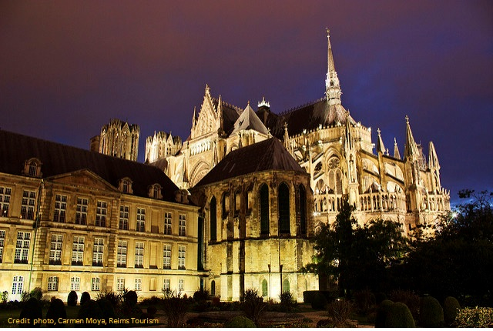
Figure 1: Cathédrale Notre-Dame de Reims © Carmen Moya 20122par Reims Tourisme
3

The formula will be presented as the following example. Equations should be centered and numbered as in Eq. 1. They can be part of the sentence, like in the electromagnetic field equation written in the form
$∇×\left(ν∇×\vec{A}\right)−{\vec{J}}_{e}+σ\frac{∂\vec{A}}{∂t}−σ\vec{v}×\vec{B}−∇×\left({\text{νμ}}_{0}\vec{M}\right)=0$ (1)
Be sure that the symbols in your equation have been defined before the equation appears or immediately following.
3. Conclusions Please pay attention to the language. If your native language is not English, please get a native English-speaking colleague to proofread your paper. Employing UK spell checker is recommended.
Acknowledgments In this section financial or other support can be acknowledged.
REFERENCES
- M. Young. The Technical Writer's Handbook (University Science, Mill Valley CA, 1989) 2nd ed.
- F. Author, S. Author and T. Author. Title of paper with only first letter capitalized. Journal name, vol. 1.

