In Memoriam: Professor Jean LÉVY

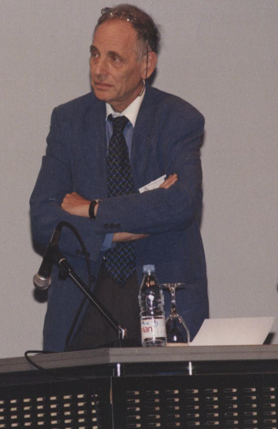 | Jean LÉVY, Emeritus Professor of Organic Chemistry at the Faculty of Pharmacy of University of Reims and former President of the French Medicinal Chemistry Society (SCT) (1991-1992) passed away at his home near Béziers (Région Occitanie, South of France) at the age of 82 years on Saturday February 17th 2018.
(1936 - 2018)

Jean Lévy studied pharmacy at the School of Pharmacy of University of Reims and in 1962 he obtained under the direction of Professor Jean Le Men his PhD, entitled "Alkaloids of Picralima nitida Stapf: structure of akuammicine, akuammidine, pseudo-akuammigine and akuammine”.
After a postdoctoral stay at Stanford University in Carl Djerassi’s lab he was nominated Assistant Professor at the Faculty of Pharmacy of University of Reims. Dr Lévy has been Professor of Organic Chemistry for more than 30 years till his retirement in 2003. In parallel, he has been the Director of the “Isolation, Structure, Transformation and Synthesis of Natural Products” CNRS Research Unit” for more than 15 years.
Professor Lévy’s main research themes concerned the chemistry indole alkaloids of biological interest. With his collaborators he developed hemi-synthetic pathways for the transformation of Aspidosperma-type alkaloids into Vinca-, Eburnea-type analogs in collaboration with OMNICHEM (Belgium). Among others, he also interested in the transformation, hemi-synthesis and total synthesis of Picralima, Aristotelia, Strychnos, Melodinus alkaloids and their analogs.
Professor Lévy was a prolific scientific author with more than 110 scientific papers and patents, he supervised more than 30 PhD theses.
He co-organized the XIIth European Colloquium on Heterocyclic Chemistry (Reims, 1986), the 21st and 33rd RICT (Rencontres Internationales de Chimie Thérapeutique) meetings, in Reims, in 1985 and 1997, respectively. He has been president of the French Medicinal Chemistry Society (SCT) (1991-92) and member of the Council of the SCT.

Professor Lévy will long be remembered as an outstanding alkaloid chemist, an excellent
mentor, a highly appreciated teacher, a wonderful colleague and friend.

Prof. Janos Sapi

