Title of Paper

Author Name ^{1*}, Author Name ², ···, Author Name ²

¹ First author’s affiliation, address
² Second author’s affiliation, address
*Corresponding author: e-mail address

Use of the template is mandatory [1]. A maximum size of two pages is required for all papers (invited and contributed).
Abstracts must be submitted prior to July 8, 2017. The presenting author must be a paid registrant. All abstracts (both MS word and it’s PDF files) should be sent in a ZIP folder to icms2017@univ-reims.fr, by e-mail. Please include your name in subject line and folder name, as well as your oral or poster preference.
Text, mathematical expressions, graphs, tables, and figures are allowed. The text must be typed with Times New Roman. The left, right, top and bottom margins should be 25 mm. The document will be printed in a A4 size and in black and white. The text should contain the following items in the exact given order and written in English:
1) Title of the paper: 14pt size font, use bold.
2) Author (initials or first names before surnames, 12pt size font), separated by commas and each followed by a footnote letter (1,2,3, ...) referring to the respective address (11 pt size font). Please draw under line in speaker.
3) Addresses, each preceded by a footnote letter referring to the respective author name(s) (11pt size font).
4) Main Text preferably should not be partioned into sections (11pt size font).
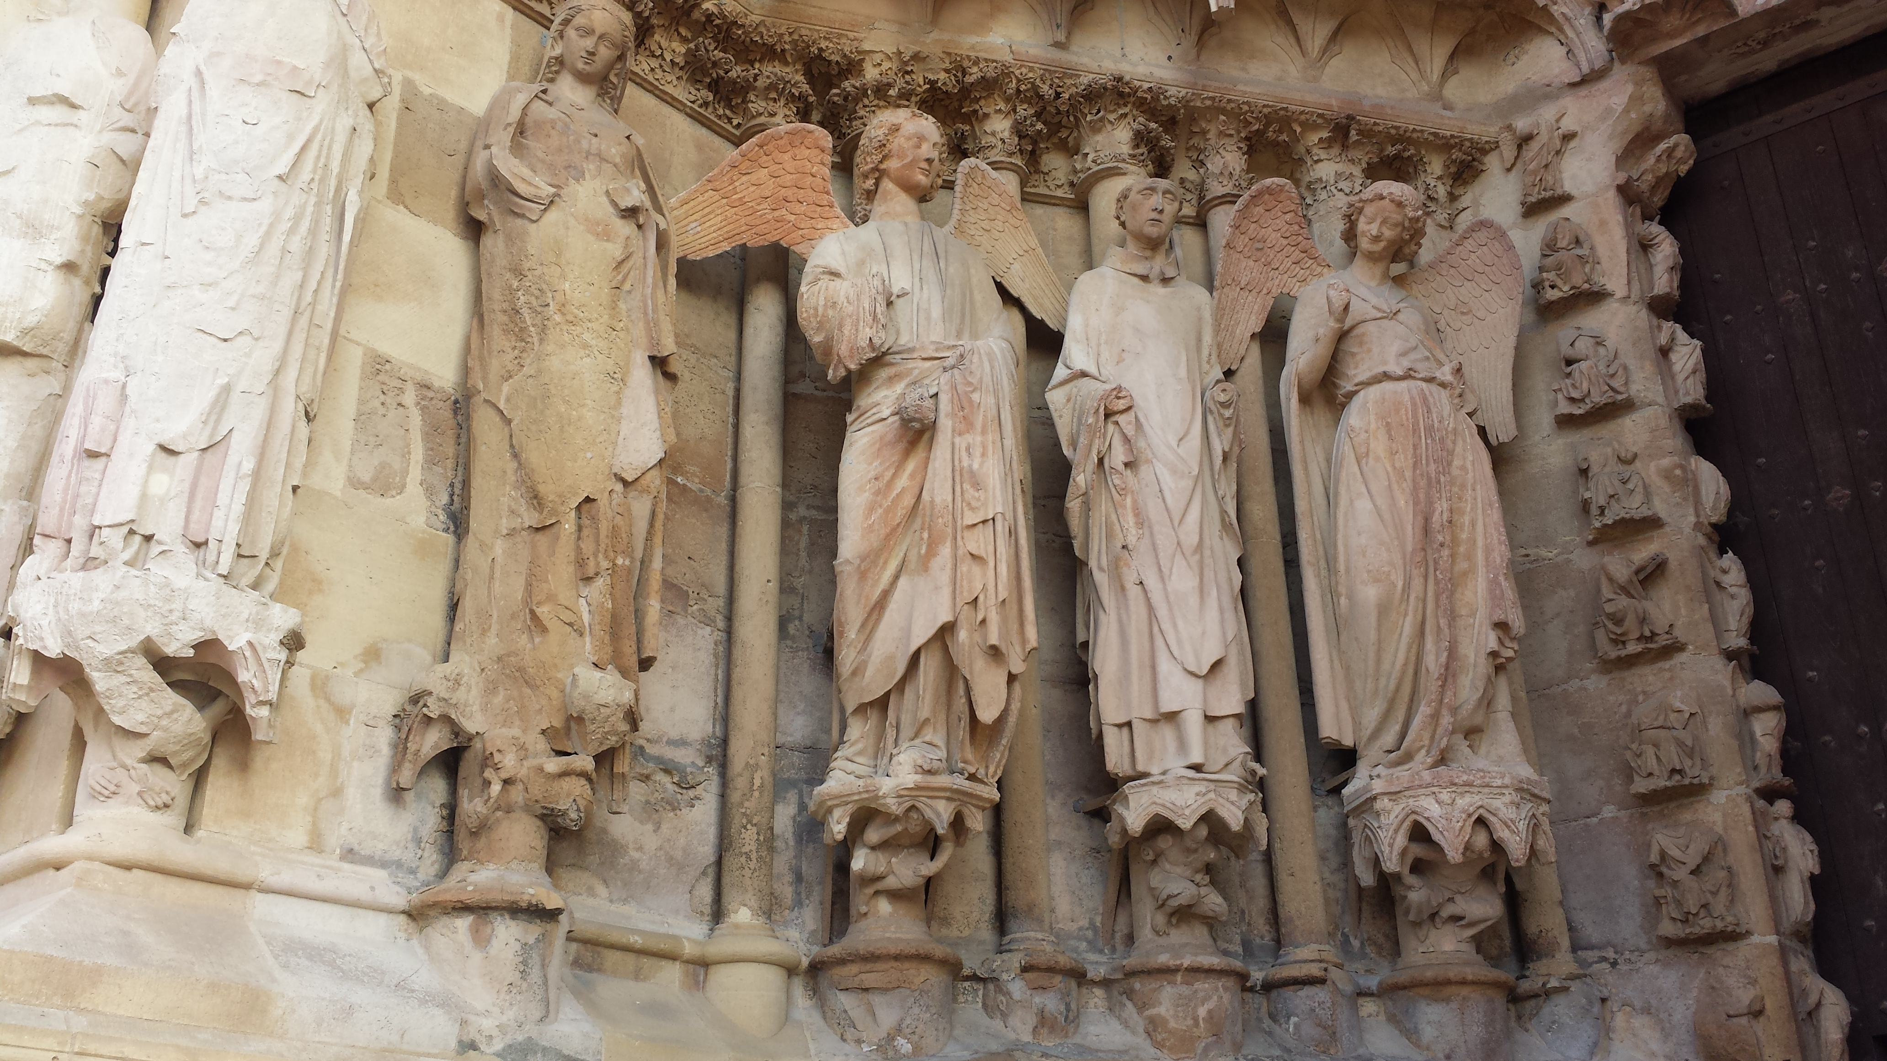
Fig. 1 North portal of Reims Cathedral west facade with the smiling angel.
5) References should be limited to the most relevant literature. They should all be cited in the text, numbered in square brackets consecutively in order of first appearance.
6) Tables should have a clear structure, with simple column headings that include all units in parentheses.
7) Figures must be sufficiently large in order for all details not to become illegible in printed form. Figure captions shoule be 11 pt size font.

Authors are asked to follow as close as possible the template provided. (Use of MS-Word is strongly recommended.)

[1] A. Bcc, D. E. Fgg, and H. Ijj, Name of the Journal 4 (2017) 1-5.

